# Place The Dice

Edit the Arrays Dice Roll HTML file to enable the user to enter a number between 1 and 6 into a text box, and click a button to make the dice image with the corresponding number display on the screen. Validate the form by displaying a red error message when the user doesn’t enter a number between 1 and 6.

# 

# Homework 5 JavaScript

1. Below is some JavaScript code embedded into a web page:

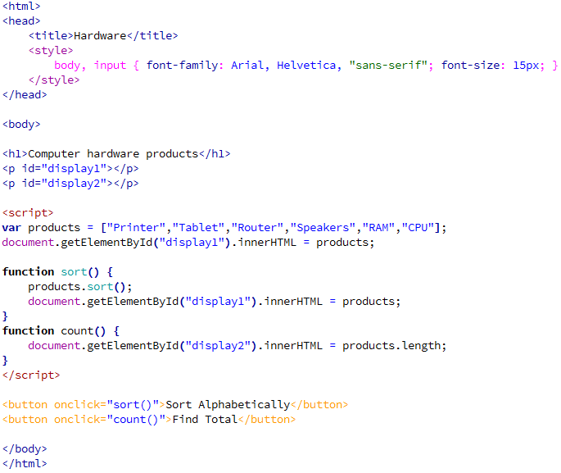

1. Describe the purpose of the function ‘count’. [1]
2. Explain the purpose of the ‘sort’ function and state the output of this function. [2]
3. Write some JavaScript code to update the ‘count’ function to display an alert message rather than updating the HTML element with the relevant information. [3]
4. Below is a HTML element:

<p id="bear"></p>

1. Write the correct JavaScript syntax to change the content of the element to display “Grizzly”. [1]
2. Write a JavaScript function called ‘Update_Image’ to update the background image in the HTML element ‘bear’ to a file called ‘Grizzly.jpg’.

Assume the image file is in the same directory as the web page. [3]

1. The web page has JavaScript code to give the user an alert box to display “Check for bears!”. Why would a web developer choose to display this element to the user of the web page within an alert box rather than within the page content? [2]
2. JavaScript is interpreted by the Browser. Explain why JavaScript is usually   
   interpreted rather than being compiled. [3]

Total Marks 15